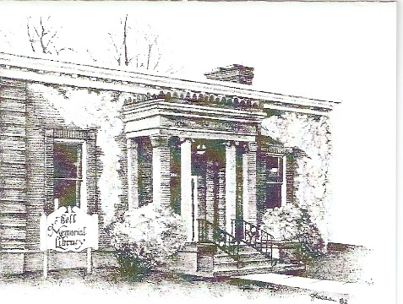

Open Meetings Policy
In accordance with New York State’s Open Meetings Law, as well as Education Law Title 1, Article 5, Section 260a, the Bell Memorial Library opens their Board of Trustee meetings to the general public. Closed, or executive, sessions may be called as a portion of the open meeting and appropriate business transacted therein.
The minutes of the open meeting and of executive session are compiled on the Library’s website and are also available upon request. The minutes of the open meeting consist of a record or summary of all motions, proposals, resolutions and any matter formally voted upon and the resulting vote. Minutes of an executive session consist of a record or summary of the final determination of any action taken and the resulting vote.
The calendar of regular Board of Trustees meetings is voted on by the Board of Trustees at their annual meeting in July. Meetings are typically scheduled for the third Thursday of each month, and held in the Library’s Meeting Room beginning at 6:30 pm. Notice of the time and place of each meeting is given to the public at least one week in advance of the meeting.

ADOPTED: 2/16/95
REVISED: 10/22/2020

